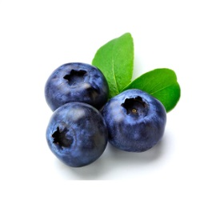  Blueberries are naturally an anti-inflammatory. Eating this yummy fruit will protect the skin from the sun and extend the life of the skin cells. | 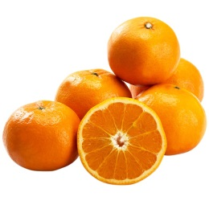  Went softer skin? Have a grapefruit for breakfast! They contain lycopene & Vitamin C, which builds collagen, protects the skin from the sun, and fights wrinkles.
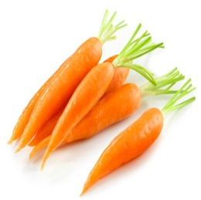  Beta carotene is highly present in carrots, which absorbs the harmful sun rays. Eating carrots will give your skin the healthy glow you long for. | 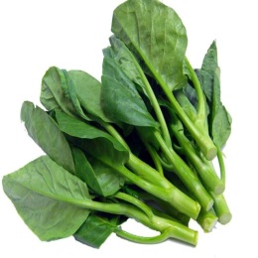  Looking to detox your skin? Start eating more kale. The large amounts of Vitamin C in kale plays a huge part in anti-aging
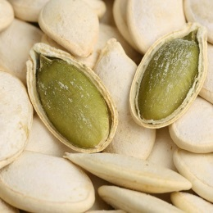  Pumpkin seeds are a great  way to tighten up your skin  They have tons of omega 3 fatty acids that build collagen, keeping the skin firm. | 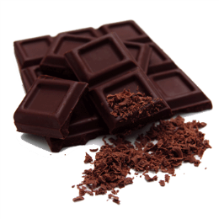  Chocolate in it is purest form, cacao is full of antioxidants known as flavonoids. Flavonoids fight the aging of skin.
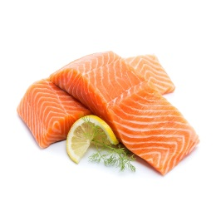  Salmon is chock full of good Fats, which will form and Maintain healthy skin cells. Salmon will retain help your Skin retain water, thus keeping It hydrated. | 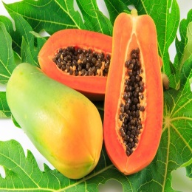  Scared of getting wrinkles? Simply eat more papaya! This fruit has TONS of antioxidants, which will prevent your skin from pesky wrinkles.
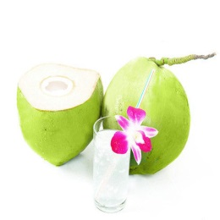  Coconut water is extremely hydrating, not only for the body, but for the skin too. Drinking coconut water hydrates and plumps up your skin | 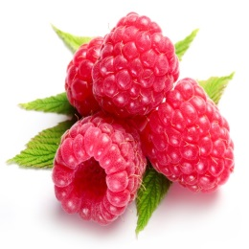  Raspberries aren’t only delicious, but they help repair and refresh damaged skin cells.
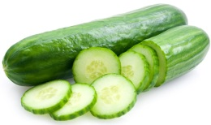  The skin of a cucumber contains tons of silica. Silica is helpful in maintaining a clear complexion, healthy teeth, and getting shiny hair! | 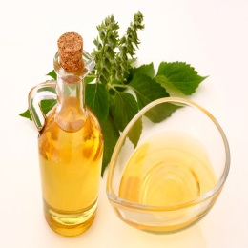  Flax is a treasure trove for alpha-linolenic acid(ALA), a plan-based omega-3 fat that’s a key component of the lubricating layer that keeps skin moist and supple. In fact, low intake of ALA can lead to dermatitis

